[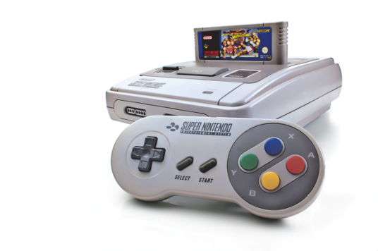](http://www.retrogamer.net/wp-content/uploads/2013/12/SNES-pad.png)**Needs and Wants!**

Mr. Poliszuk

Technology 7

|  |  |
| --- | --- |
| Define: Need –  Want – | |
| Identify at least 5 examples of a **Need** (internet pictures): | |
| Identify at least 5 examples of a **Want** (internet pictures): | |
| Think about your possessions at home, or here in the classroom, and determine 5 items that are **Needs**.  1.)  2.)  3.)  4.)  5.) | Think about your possessions at home, or here in the classroom, and determine 5 items that are **Wants**.  1.)  2.)  3.)  4.)  5.) |
| Argue whether **Money**, in today’s society, is a Need or a Want. Explain. | |

East Lower School – Rochester City School District